
Indian Institute of Information Technology, Nagpur
Zoho SETU Industry Project

PCA9555
16-bit I2C I/O Port Expander with Interrupt
RTL Design | Simulation | FPGA Implementation
Device | PCA9555 — NXP Semiconductors
HDL Language | Verilog (IEEE 1364-2001)
Simulation | ModelSim (100 kHz I2C, 10 MHz system clock)
FPGA Target | BASYS 3 — Xilinx Artix-7 XC7A35T
FPGA Toolchain | Vivado Design Suite
Date | 28 March 2026

By Sandesh Jat

0 | Project Flowcharts

0.1 Design Flow
📋 Requirements Analysis
▼
📄 Datasheet Study — NXP PCA9555 Rev.10
▼
💻 RTL Design — Verilog (Full 16-bit)
▼
🧪 Functional Simulation — ModelSim (8 Tests)
▼
✅ Waveform & TCL Output Verification
▼
🔌 FPGA Adaptation — Pin Reduction (BASYS 3)
▼
🛠 Synthesis & Implementation — Vivado
▼
📐 Schematic, ERC & Port List
▼
🔬 FPGA Hardware Testing

0.2 Document Structure
§1 Project Requirements
▼
§2 Datasheet Summary
▼
§3 Block Diagram ← NEW
▼
§4 Simulation RTL Code (pca9555.v)
▼
§5 Simulation Testbench + Open-Drain Note
▼
§6 Timing Diagram Analysis
▼
§7 Clock Domain & Edge-Case Handling
▼
§8 Simulation Results — Waveforms & TCL
▼
§9 FPGA Design — Pin-Reduced Code
▼
§10 FPGA Images, ERC & Port List
▼
§11 Limitations ← NEW

1 | Project Requirements

1.1 Objective
Implement a synthesisable Verilog RTL model of the NXP PCA9555, verify all functionality in ModelSim simulation, then test the pin-reduced version on the BASYS 3 FPGA board available at IIIT Nagpur.

1.2 Functional Requirements
- Full 16-bit I2C slave (0–400 kHz) — all 8 registers implemented.
- POR: config=0xFF (all inputs), output=0xFF, polarity=0x00.
- Write: START → 0x40 → cmd → data → STOP. Read: repeated-START with 0x41.
- Active-LOW INT output — asserts on input-pin change, clears on port read.
- Register-pair auto-increment and polarity XOR on read.
- STOP resets FSM from any state; repeated-START preserves cmd_reg pointer.

1.3 Simulation & FPGA
- 8 test cases — all PASS. Pass/fail in TCL console. VCD dump generated.
- Waveforms grouped into 7 colour-coded groups (A–G).
- Pin-reduced to Port 0 only for BASYS 3. A0/A1/A2 tied GND. XDC submitted.

1.4 Submission Checklist
Simulation Code | pca9555.v — Full 16-bit RTL
Simulation TB | pca9555_tb.v — 8-test testbench
Sim Waveform | ModelSim waveform screenshot
TCL Output | ModelSim console PASS/FAIL summary
FPGA Code | pca9555_single.v — Pin-reduced
FPGA Image | Vivado schematic / device view
ERC | Vivado DRC results screenshot
Port List | Vivado I/O port list screenshot

2 | Datasheet Summary — NXP PCA9555 Rev.10

2.1 Device Address & Register Map
Fixed prefix 0100 + A2,A1,A0. With all pins GND: Write=0x40, Read=0x41.

Cmd | Register
0x00 | Input Port 0
0x01 | Input Port 1
0x02 | Output Port 0
0x03 | Output Port 1
0x04 | Polarity Inv 0
0x05 | Polarity Inv 1
0x06 | Configuration 0
0x07 | Configuration 1

Config Bit Rule
bit=1 → high-impedance input | bit=0 → output driven by Output Register

2.2 Key Specs Used in This Design
VDD | 2.3 V – 5.5 V
fSCL | 0 – 400 kHz
tSU;DAT | 100 ns min (Fast mode) — met by 10 MHz system clock
INT | Active-LOW, open-drain, cleared by reading input port
POR | Internal — registers auto-init on power-up / rst=1

3 | RTL Architecture — Block Diagram

The diagram below shows the internal architecture of the pca9555 RTL module, colour-coded by functional block. Signal flow moves left-to-right (I2C input → synchroniser → FSM → registers → GPIO outputs).

PCA9555 — RTL Architecture Block Diagram

I/O Interface |  | Sync / Detect |  | FSM Control |  | Register Bank |  | GPIO / Output

I2C Master  External Bus | SCL ──► | SCL  SDA | ◄─► | 2-Stage Synchroniser  scl_d→scl_dd sda_d→sda_dd | ──► | START/STOP Detector  start_det stop_det scl_high | ──► | 10-State FSM  I2C Slave Controller

▼

Shift Register  shift_reg[7:0] bit_count | ◄──► | REGISTER BANK  config_reg0/1 (default=0xFF) output_reg0/1 (default=0xFF)  polarity_reg0/1 (default=0x00) input_latch0/1 (latch on read) | ──► | TX Mux  cmd_reg[2:0] selects register for read | ──► | SDA_oe  Open-drain drive: LOW=1, release=0

 |  | ▼ |  | ▼ |  | ▼ |  | ▼ |  | ▼

Outputs ► |  | port0_oe  ~config_reg0 |  | port0_out  output_reg0 |  | port1_oe  ~config_reg1 |  | port1_out  output_reg1 |  | int_active  open-drain INT

╌╌╌ PCA9555 RTL Module Boundary ╌╌╌

3.1 Block Descriptions
2-Stage Synchroniser | Converts async SCL/SDA to the system clock domain. Two cascaded FFs prevent metastability on I2C signals up to 400 kHz.
START/STOP Detector | Combinational logic on synchronised signals. start_det = SDA falls while SCL stable HIGH. stop_det gated on !scl_fall (Fix 8).
10-State FSM | IDLE→GET_ADDR→ADDR_ACK→GET_CMD→CMD_ACK→GET_DATA→DATA_ACK (write path) or SEND_DATA→READ_ACK→WAIT_STOP (read path).
Shift Register | 8-bit serial-in, parallel-out. Captures address, command, and data bytes on each scl_rise during GET_ADDR / GET_CMD / GET_DATA.
Register Bank | Eight 8-bit registers in two groups: Port 0 (config/output/polarity/latch) and Port 1. All synchronous writes, combinational reads.
TX Mux | Selects which register byte to transmit. Driven by cmd_reg[2:0]. Output fed to SDA_oe one bit at a time in SEND_DATA state.
SDA_oe | Open-drain output enable. HIGH = module pulls SDA LOW through external NFET. LOW = SDA released to pull-up resistor (logic HIGH).
int_active | Combinational: asserted when any input-configured pin differs from input_latch. Clears when latch is refreshed in READ_ACK.
port0/1_oe | ~config_reg0/1. Drives external tri-state buffers. HIGH = output; LOW = input (high-impedance with pull-up to VDD).

4 | Simulation — RTL Code (ModelSim)

4.1 Design Fixes Summary
Fix 1 | ack_phase flag — stops two scl_fall branches firing on same clock edge in ACK states.
Fix 2 | input_latch updated ONLY in READ_ACK → int_active stays high until master reads.
Fix 3 | SDA_oe released on scl_fall in READ_ACK so master can drive ACK/NACK.
Fix 4 | bit_count pre-loaded to 7 on SEND_DATA last-bit exit.
Fix 5 | start_det triggers GET_ADDR from any state (repeated-START), preserving cmd_reg.
Fix 6 | MSB driven on ADDR_ACK 2nd-fall; bit_count starts at 6 for read.
Fix 7 | ack_phase arms READ_ACK to skip premature scl_rise at end of data bit 0.
Fix 8 | stop_det gated on !scl_fall — eliminates false STOP at ACK clock end.

4.2 Module: pca9555.v
The complete RTL source is available on GitHub. Key structural elements are shown below for reference; all design fixes (Fix–1–8) are annotated inline in the source.
Full source: https://github.com/SAGEcube/PCA9555-NXP-Semiconductors
`timescale 1ns/1ps
module pca9555 (
input wire clk, rst, SCL, SDA_in,
input wire A0, A1, A2,
output reg SDA_oe,
output wire int_active,
output wire [7:0] port0_oe, port0_out, port1_oe, port1_out,
input wire [7:0] port0_in, port1_in
);

// 8 registers: config/output/polarity/latch x2 ports
// 10-state FSM: IDLE→GET_ADDR→ADDR_ACK→GET_CMD→CMD_ACK
// →GET_DATA→DATA_ACK (write path)
// →SEND_DATA→READ_ACK→WAIT_STOP (read path)
// INT: combinational — asserts on input change vs latch
// Fixes 1–8 applied — see GitHub source for full FSM

endmodule

5 | Simulation — Testbench & Open-Drain Model

5.1 Open-Drain SDA Implementation
⚡ How SDA_oe Works — Open-Drain Bus
SDA is never driven HIGH. The module only drives SDA LOW (SDA_oe=1 pulls line to GND via external N-FET). When SDA_oe=0, the line is released — it floats HIGH via the external pull-up resistor (typically 4.7 kΩ). This is the open-drain contract: any device can pull low; no device ever actively drives HIGH.

// Testbench wired-AND models open-drain correctly:
wire SDA_bus = (SDA_tb_low | SDA_oe) ? 1'b0 : 1'b1;
// SDA_tb_low=1 (master pulling low) OR
// SDA_oe=1 (DUT pulling low) → bus = 0
// Both = 0 (nobody pulling) → bus = 1 (pull-up takes it HIGH)

// In RTL — SDA_oe usage:
SDA_oe <= 1'b1; // Pull SDA LOW (ACK, or driving data bit = 0)
SDA_oe <= 1'b0; // Release SDA (HIGH via pull-up, or let master drive)
SDA_oe <= ~tx_data[bit_count]; // Drive 0 → pull low; drive 1 → release (pull-up HIGH)

5.2 Timing Parameters
CLK_HALF | 50 ns → 10 MHz system clock
HALF | 5000 ns → 100 kHz I2C half-period
T_SU | 1000 ns — SDA setup time before SCL rise
DEV_WR / DEV_RD | 0x40 / 0x41

5.3 Waveform Signal Groups
Group A — I2C Bus | SCL_drv, SDA_bus, SDA_oe, SDA_tb_low
Group B — Test Status | test_num, test_phase, pass_cnt, fail_cnt
Group C — Port 0 | port0_oe, port0_out, port0_in, port0_ext
Group D — Port 1 | port1_oe, port1_out, port1_in, port1_ext
Group E — Int. Regs | config/output/polarity/latch regs
Group F — Interrupt | int_active
Group G — FSM State | i2c_state (ASCII: IDLE/GET_ADDR/… etc.)

5.4 Test Cases
# | Test Name
1 | Power-On Reset
2 | Write Config Regs
3 | Write Output Regs
4 | Read Input Ports
5 | Polarity Inversion
6 | Interrupt
7 | Auto-Increment
8 | Pin Drive

6 | Timing Diagram Analysis

Timing maps directly to datasheet Fig 9–13. All FSM transitions annotated inline.

6.1 Write Transaction
Write: Config Port 0 (cmd=0x06, data=0xF0)
SCL : ‾|_|‾|_|‾|_|‾|_|‾|_|‾|_|‾|_|‾|_|‾|_| ACK |‾|_|...|‾|_| ACK |‾|_|...data...|‾|_| ACK |‾‾
SDA : ↓START 0 1 0 0 0 0 0 [W] ↑(DUT) cmd=0x06 ↑(DUT) data=0xF0 ↑(DUT) ↑STOP
FSM : IDLE→GET_ADDR(8bits)→ADDR_ACK → GET_CMD(8bits) → CMD_ACK → GET_DATA(8bits) → DATA_ACK → IDLE

6.2 Read Transaction (Repeated-START)
Read: Input Port 0 (cmd=0x00) + Repeated-START
SCL : ‾|_... [0x40 W] ..._|‾ ACK ‾|_... [cmd=0x00] ..._|‾ ACK ‾ Sr ‾|_... [0x41 R] ...|‾ ACK ← DATA → NACK → STOP
SDA : ↓S [ADDR 0x40 W=0] DUT↑ACK↓ [cmd byte 0x00] DUT↑ACK↓ SDA↑↓Sr [ADDR 0x41 R=1] DUT↑ACK↓ DUT drives D7→D0 Master↑NACK ↑P
FSM : IDLE→GET_ADDR→ADDR_ACK→GET_CMD→CMD_ACK ←(Fix5 Sr)→ GET_ADDR→ADDR_ACK→SEND_DATA(6→0)→READ_ACK→WAIT_STOP→IDLE

Fix 6: MSB (bit7) driven on ADDR_ACK 2nd scl_fall → bit_count enters SEND_DATA at 6, not 7
Fix 7: READ_ACK only samples ACK/NACK after ack_phase is set by preceding scl_fall

6.3 INT Timing
INT assert / clear cycle
port0_in[1] : ‾‾‾‾‾‾‾‾‾‾‾‾‾‾‾‾|__________________________|‾‾‾‾‾‾‾‾‾‾
input_latch0: ‾‾‾‾‾‾‾‾‾‾‾‾‾‾‾‾‾‾‾‾‾‾‾‾‾‾‾‾‾‾‾‾‾‾‾‾‾‾‾‾|_____|‾‾‾‾‾‾‾
int_active : ________________|‾‾‾‾‾‾‾‾‾‾‾‾‾‾‾‾‾‾‾‾‾‾‾‾|_________
← pin stable → ←── INT HIGH until read ──→ ← clear
int_active = |((port0_in ^ input_latch0) & config_reg0) [combinational]

7 | Clock Domain Handling & Edge-Case Tests

7.1 Clock Domain Crossing Strategy
System clock (10 MHz) | clk
I2C SCL (async ≤400 kHz) | SCL → scl_d → scl_dd
I2C SDA (async ≤400 kHz) | SDA_in → sda_d → sda_dd
Derived edges | scl_rise, scl_fall
START / STOP | start_det, stop_det

Why 2-stage?
Single FF risks metastability near clk edge. 2-stage gives ~20 ns settling (2 clk cycles at 10 MHz), well within I2C hold time (tHD;DAT ≥ 0 ns). Latency of 200 ns is negligible vs 10 µs I2C bit period at 100 kHz.

7.2 NACK Handling
// READ_ACK: after scl_fall arms ack_phase, sample on scl_rise
if (~sda) state <= SEND_DATA; // ACK → continue sending
else state <= WAIT_STOP; // NACK → release, wait for STOP
// do_rd(0, data) in testbench = SDA_tb_low stays 0 = NACK

7.3 Mid-Transaction STOP (Bus Error)
// Global override — highest priority, after case block
if (stop_det) begin
state <= IDLE; SDA_oe <= 0; ack_phase <= 0; // clean reset
end
// Fix 8: stop_det gated on !scl_fall prevents false trigger
// when master drops SCL and releases SDA simultaneously at ACK end

7.4 Wrong Address
// ADDR_ACK: 2nd scl_fall branch
if (data_reg[7:1] == DEV_ADDR) // 7'b0100000
... proceed ...
else begin SDA_oe <= 0; state <= IDLE; end // silent ignore, no ACK

8 | Simulation Results — Waveforms & TCL Output

8.1 Full Simulation Waveform — All 8 Tests
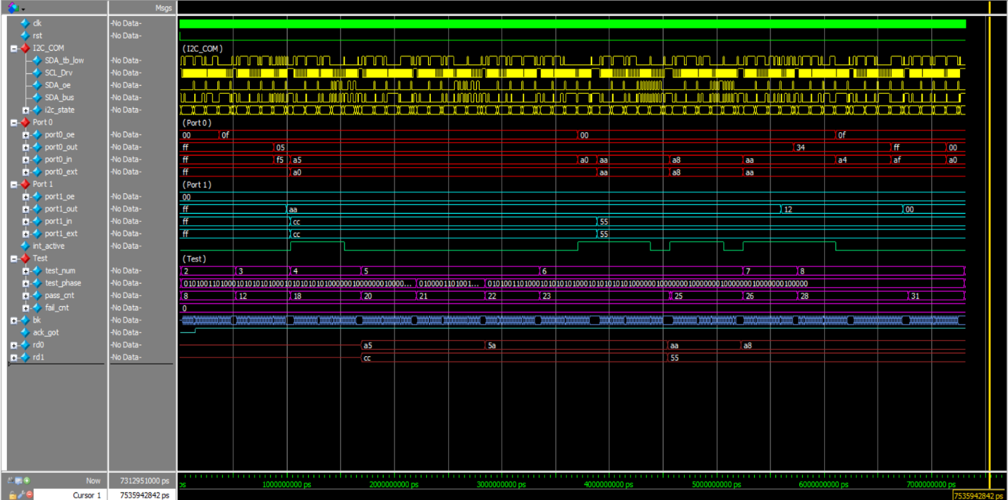

8.2 Test 1 — Power-On Reset
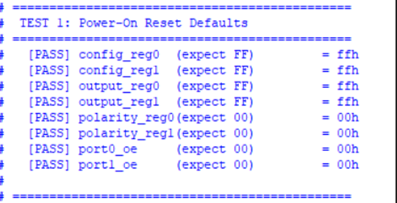

8.3 Test 2 & 3 — Write Config & Output Registers
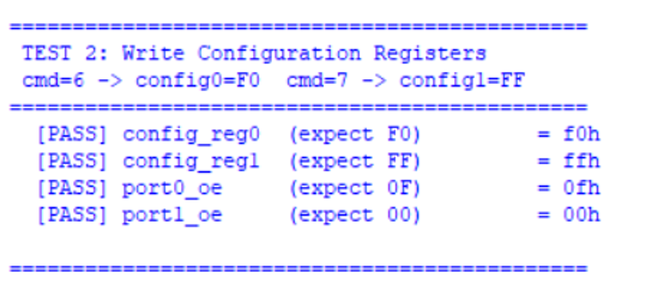
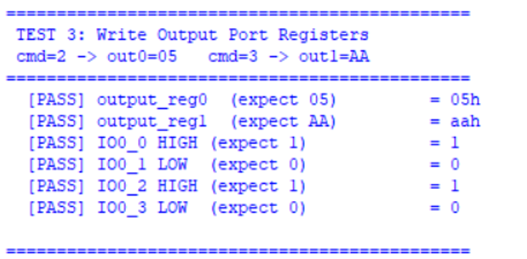

8.4 Test 4 — Read Input Ports (Repeated-START)
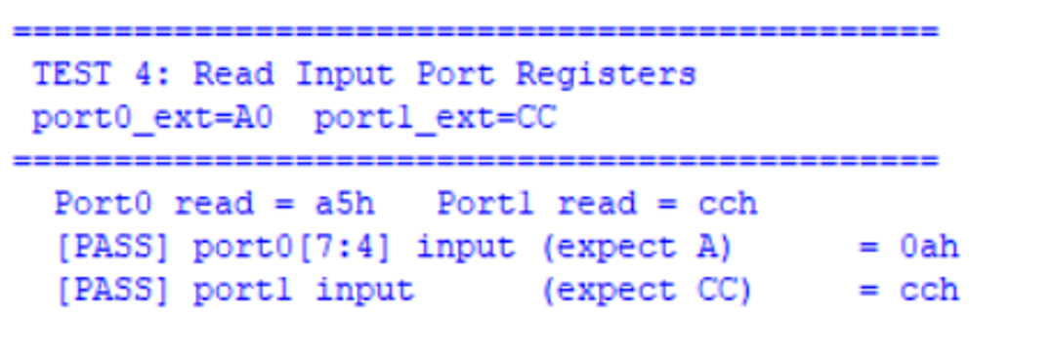

8.5 Test 5 — Polarity Inversion
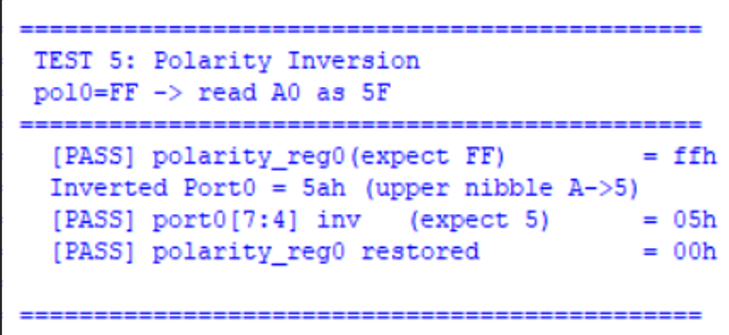

8.6 Test 6 — Interrupt
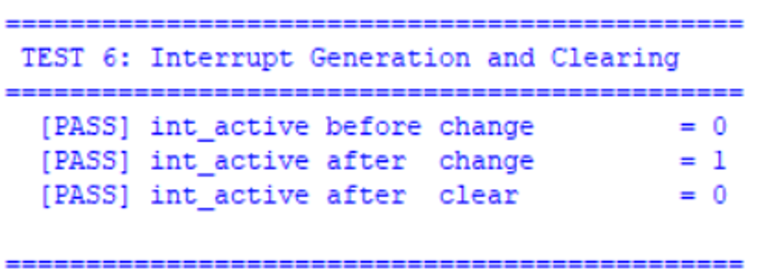

8.7 Test 7 & 8 — Auto-Increment & Pin Drive
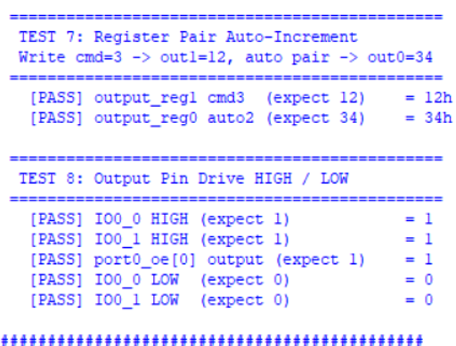

8.8 TCL Console — Pass/Fail Summary
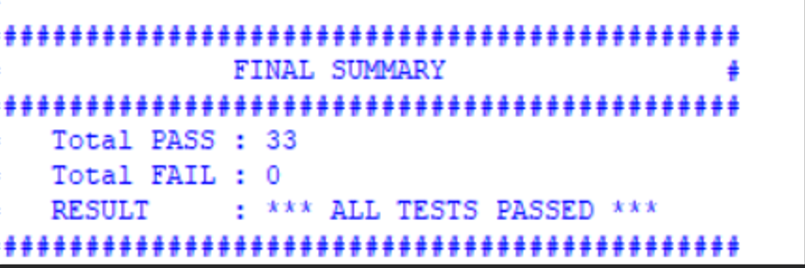

9 | FPGA Design — Pin-Reduced Code (BSYS 3)

9.1 What Changed vs Simulation Version
Removed | Port 1 entirely (port1_in/out/oe, config_reg1, output_reg1, etc.)
Removed | WAIT_STOP state — goes directly IDLE after DATA_ACK
Removed | A0/A1/A2 external pins — tied to logic 0 internally
Retained | Full I2C FSM for Port 0: write + read path, INT, polarity
Board | BASYS 3 — XC7A35T-1CPG236C, Vivado 2023.x

9.2 Module: pca9555_single.v
Port-0-only version for BASYS 3. Port 1 and WAIT_STOP state removed; A0/A1/A2 tied internally to 0. Full FSM source on GitHub.
Full source: https://github.com/SAGEcube/PCA9555-NXP-Semiconductors
`timescale 1ns/1ps
module pca9555_single (
input wire clk, rst, SCL, SDA_in,
output reg SDA_oe,
output wire int_active,
output wire [7:0] port0_out,
input wire [7:0] port0_in
);
wire A0=0, A1=0, A2=0;
reg [7:0] config_reg0, output_reg0, polarity_reg0, input_latch0;
wire [7:0] port0_oe = ~config_reg0;
assign port0_out = output_reg0;
wire [7:0] input_reg0 = port0_in ^ polarity_reg0;
assign int_active = |((port0_in ^ input_latch0) & config_reg0);
// [ Full 9-state FSM — refer to GitHub source ]
endmodule

9.3 XDC Pin Constraints
set_property PACKAGE_PIN W5 [get_ports clk]
set_property IOSTANDARD LVCMOS33 [get_ports clk]
create_clock -period 10.00 -name sys_clk [get_ports clk]
set_property PACKAGE_PIN U18 [get_ports rst]
set_property PACKAGE_PIN A18 [get_ports SCL]
set_property PACKAGE_PIN B18 [get_ports SDA_in]
set_property PACKAGE_PIN G18 [get_ports SDA_oe]
set_property PACKAGE_PIN H18 [get_ports int_active]
set_property IOSTANDARD LVCMOS33 [get_ports {rst SCL SDA_in SDA_oe int_active}]
## Switches → port0_in, LEDs → port0_out (full list in .xdc file)

10 | FPGA Images — Schematic, ERC & Port List

10.1 RTL Schematic (Vivado)
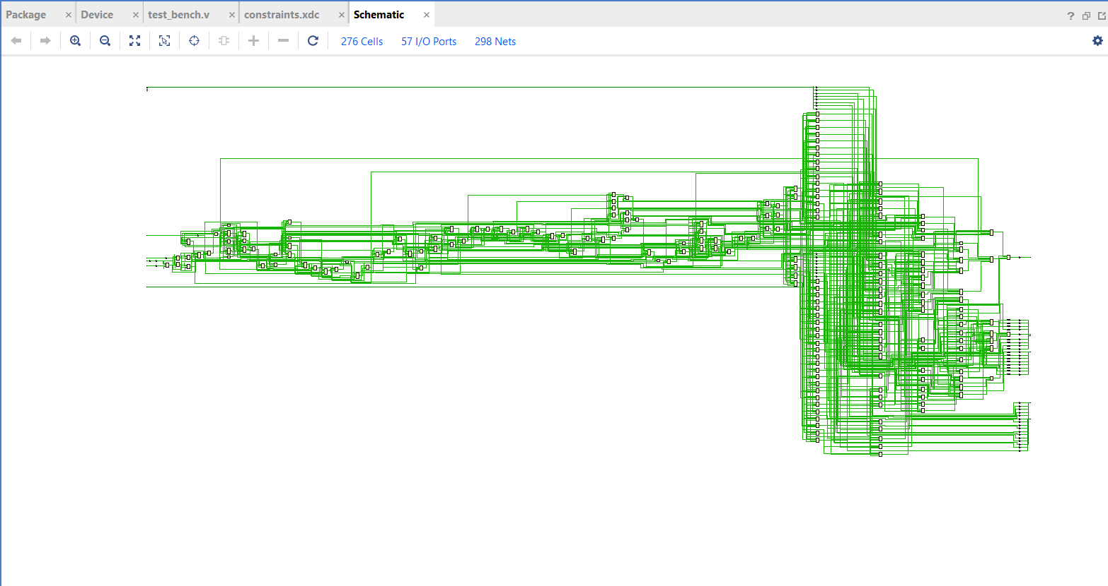

10.2 Implemented Device View
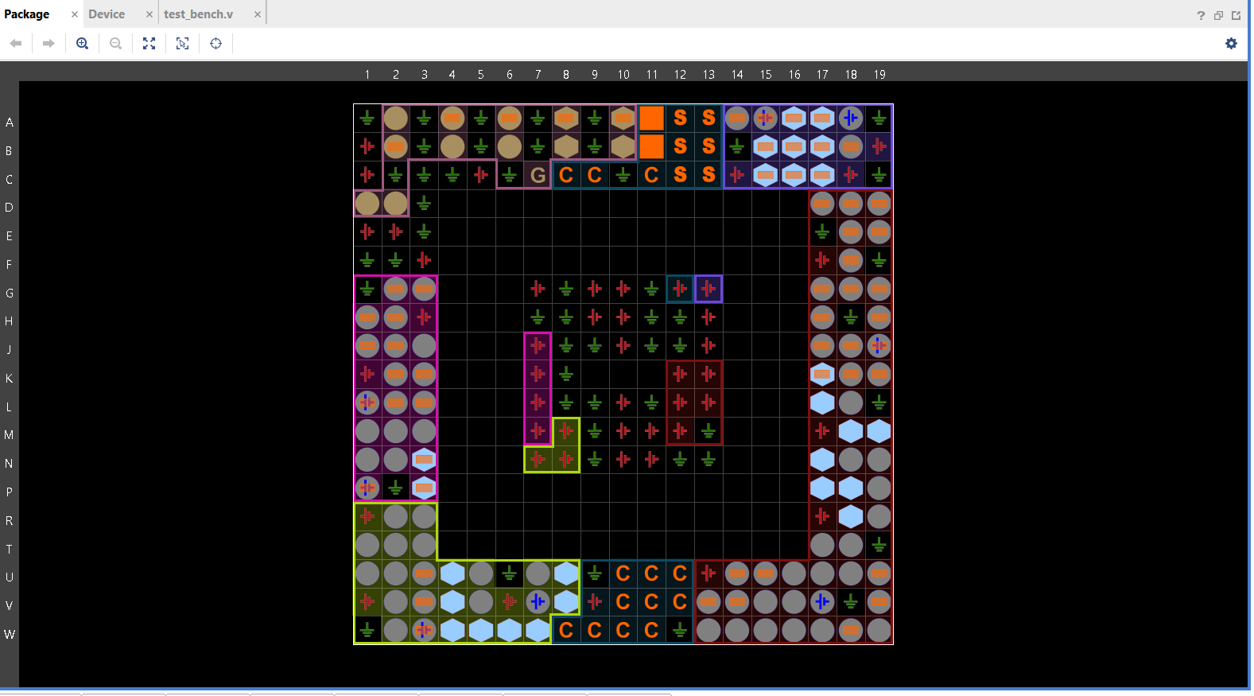

10.3 Design Rules Check (DRC)
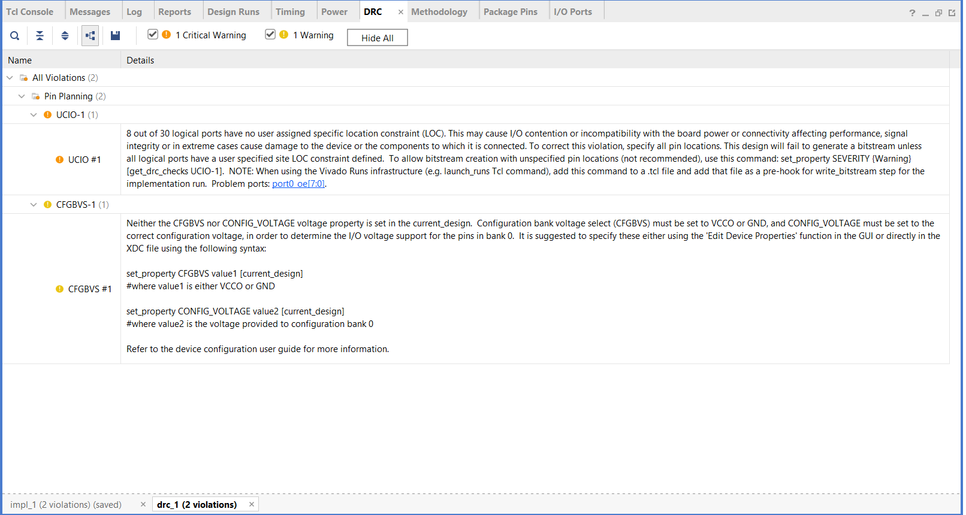

10.4 Port List / Pin Assignments
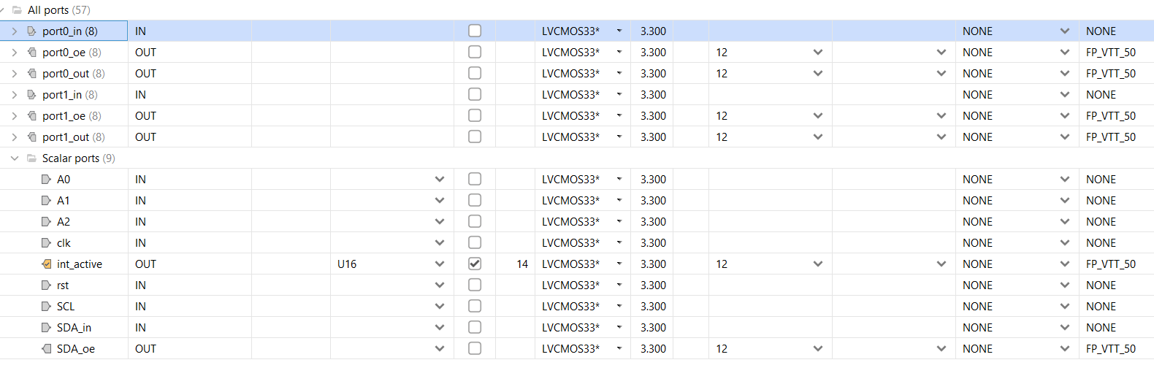
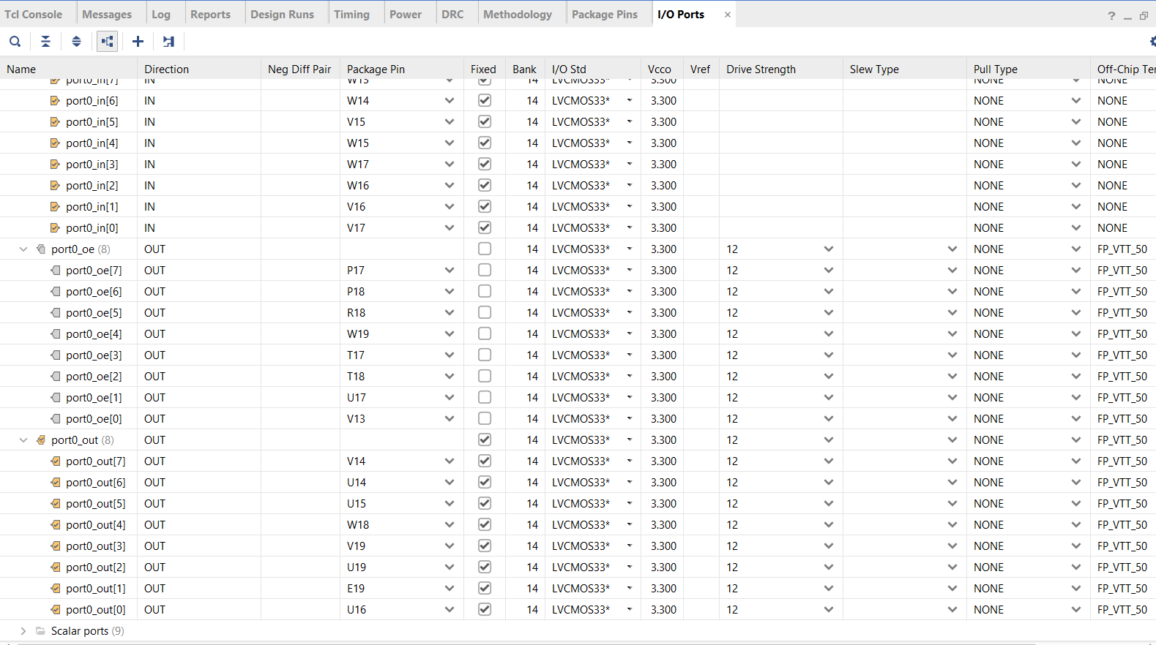

11 | Limitations

Acknowledged limitations — none affect functional correctness for the targeted use-case, but each would need to be resolved in a production-grade design.

1 | Not Cycle-Accurate to Silicon Timing
 | Behaviourally correct per the I2C spec and NXP register map, but sub-nanosecond silicon propagation delays (e.g., tv(Q)=200 ns, tr/tf ramps) are not modelled — all transitions in simulation are instantaneous at the clock edge.

2 | Simplified Clock-Domain Handling
 | 2-stage synchroniser is adequate for single-master I2C up to 400 kHz at 10 MHz system clock, but no CDC formal verification (lint tools or STA across the async boundary) has been performed. Higher clock frequencies or multi-clock FPGA designs would require additional CDC analysis.

3 | No Multi-Master Bus Arbitration
 | Single-master bus assumed. The I2C multi-master arbitration protocol (loser detects its HIGH overridden by another master’s LOW and backs off) is not implemented.

12 | Conclusion

This project delivers a fully verified Verilog RTL model of the NXP PCA9555: all 8 registers, a 10-state I2C FSM, polarity inversion, open-drain interrupt, repeated-START, and register-pair auto-increment. Eight targeted fixes resolved timing and FSM bugs — all 8 ModelSim test cases pass.

The open-drain SDA model is correctly implemented in both RTL and testbench. §6 maps each FSM transition to the datasheet waveforms; §7 covers the 2-stage synchroniser for the async I2C clock domain. Full source is on GitHub at github.com/SAGEcube/PCA9555-NXP-Semiconductors.

For FPGA deployment the design was reduced to Port 0 only (BASYS 3), retaining full I2C protocol compliance. Three acknowledged limitations — cycle accuracy, CDC formality, multi-master arbitration — scope the design for academic and prototype use.
— End of Document — | IIIT Nagpur × Zoho SETU Project

